**New PARTcommunity plugin gives CorelCAD users access to Millions of 3D and 2D CAD models**

Free plugin makes it easy to access CADENAS 3D CAD manufacturer catalogs directly within CorelCAD

**Germany, Augsburg, 7th July 2016.** CADENAS announces the introduction of the PARTcommunity plugin that gives CorelCAD™ users access to millions of free CAD models from hundreds of renowned manufacturers. With PARTcommunity, CorelCAD users can easily insert CAD models as blocks with attributes into their CorelCAD designs in 3D or a selection of 2D views. The PARTcommunity plug-in is now available free to CorelCAD 2015.5, CorelCAD 2016 and CorelCAD 2016.5 registered users at www.corelcadmarket.com.

Integrated directly into the CorelCAD user interface, the PARTcommunity plugin enables users to search, select and then customize models for their particular project from a variety of renowned, international manufacturers catalogs. In addition to a wide selection of free content, PARTcommunity also gives CorelCAD users access to premium, paid-for standardized CAD models which are independent of specific manufacturers, ideal when responding to a call for tenders.

“We are pleased to announce our new PARTcommunity plugin for CorelCAD, which will enable engineers to make their design processes in an even more time-saving fashion”, says Jürgen Heimbach, CEO of the CADENAS GmbH.

Compatible with CorelCAD 2015.5 and higher, the free PARTcommunity plugin is available through the [Graebert Market for CorelCAD](http://www.corelcadmarket.com) at www.corelcadmarket.com. The PARTcommunity plugin for CorelCAD was developed by the software manufacturer CADENAS GmbH in Augsburg in cooperation with the Graebert GmbH in Berlin.

CorelCAD is an affordable and powerful CAD software solution for precise 2D drafting and 3D design. With industry-standard CAD features and advanced .DWG file support, it is a true CAD solution for architectural and mechanical CAD needs, available as a hybrid desktop application for Windows and Mac OS X.

For more information about CorelCAD, please visit: [www.coreldraw.com/corelcad](http://www.coreldraw.com/corelcad?utm_source=CORPnewsRelease&utm_medium=media&utm_campaign=SMPRDRAW).

**Press Images:**

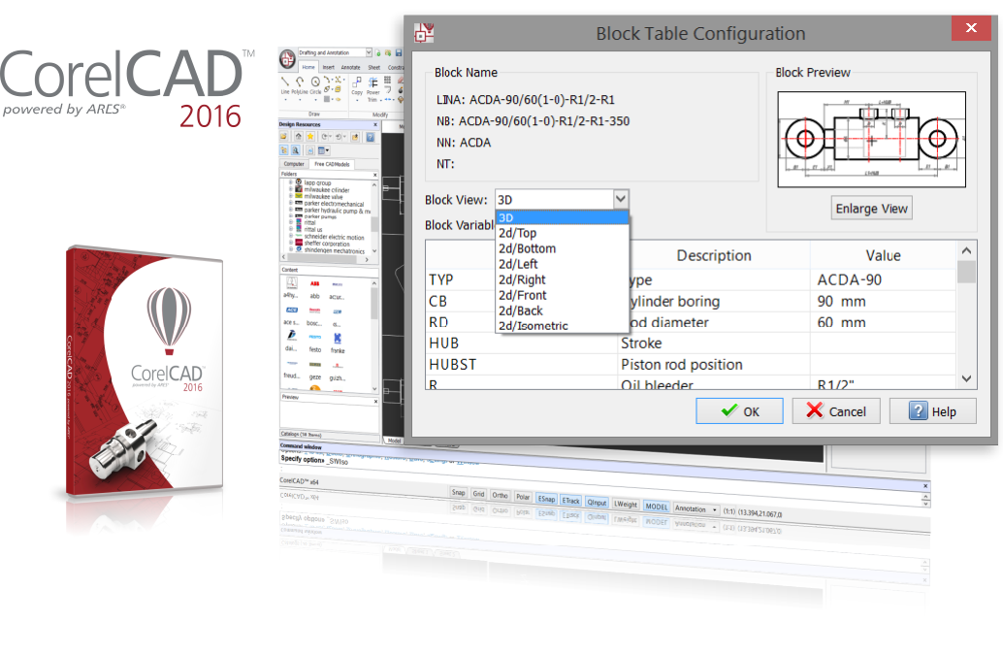

**Caption:** With PARTcommunity, CorelCAD users can easily insert CAD models as blocks with attributes into their CorelCAD designs in 3D or a selection of 2D views.

This press release and accompanying images are available for download from our website: [www.cadenas.de/press/press-releases](http://www.cadenas.de/press/press-releases)

**About CADENAS**

CADENAS is a leading software developer in the areas of Strategic Parts Management and parts reduction (PARTsolutions), as well as Electronic Product Catalogs (eCATALOGsolutions). With its customized software solutions, the company acts as a link between the component manufacturers with their products and the purchasers.

With its 300 employees at 17 international subsidiaries, the name CADENAS (Hispanic: process chains) has been standing for success, creativity, support and process optimization since 1992.

For further information, please visit: www.cadenas.de/en